Birla Vishvakarma Mahavidyalaya Engineering College
[An Autonomous Institution]

A
Project Report On

NotesHub – A Version-controlled Knowledge management system

Under the course of
DESIGN ENGINEERING -3CP08
B. E. Semester – VI
(Computer Engineering)

Submitted by:
Sr. | Name of student | ID No.
1 | Het Soni | 23CP050
2 | Meet Patel | 23CP054

Academic year (2025-2026)

CERTIFICATE
This is to certify that the students namely,
Het Soni (23CP050) of B. E. (Computer Engineering) Semester VI have successfully completed the course work and related tasks for the course of Design Engineering 3CP08 during the academic term ending in the month of April 2025.

Date: 10/04/26

Faculty Signature

Contents

- Introduction
- Literature Review
- Design Considerations for detail design –DFD, ER and UML diagrams
- Canvases
- Prototype, Implementation/ Simulation
- Conclusion and Future scope
- Reference

ABSTRACT

In today’s academic world, students organize their study resources through various platforms like messaging apps, PDF documents, online resources, and even physical notepads. This causes fragmentation, problems with revising, and discontinuity of knowledge.

NotesHub is an academic notes management system that utilizes Git’s principles for version control. NotesHub uses snapshotting, restore feature, and note linkage to form a systematic knowledge base. The application guarantees security during the editing process and keeps track of all changes made to maintain the development journey of the user’s learning process.

Spring Boot and PostgreSQL are used for implementing the backend of the NotesHub. The project emphasizes the implementation of design engineering in practical case

CHAPTER 1

INTRODUCTION

Problem Statement
The students have problems with organizing the information in the following ways:

- Separation of notes in many places
- Absence of version control
- Overwriting of crucial information
- Revisions are hard to do
- Not having links between relevant information

It leads to ineffective learning process.

Project Objectives

The goals of NotesHub include:

- The design of an integrated notetaking system
- Version control to manage educational notations
- The provision of restore feature for secure editing
- Conceptual linkage capability
- Scalability and modularity of the backend
- Revision enhancement and knowledge management

CHAPTER 2

LITERATURE REVIEW AND PROJECT

METHODOLOGY

Literature Review

There already exist tools like Notion, OneNote, and Obsidian that offer note-taking functionality but fail to offer:

- Version History Structure
- Restore Functionality
- Academic-Focused Features
- Linking of Concepts

Git, which is a version control system, uses snapshots to maintain history. The current project adopts a similar approach for academic purposes.

Methodology

The design of this system is done based on Design Engineering methodology, which includes:

- Problem Identification
- User Analysis
- Ideation
- System Design
- Implementation
- Testing & Evaluation

CHAPTER 3

Design Considerations For Detail Design

NotesHub ER Diagram
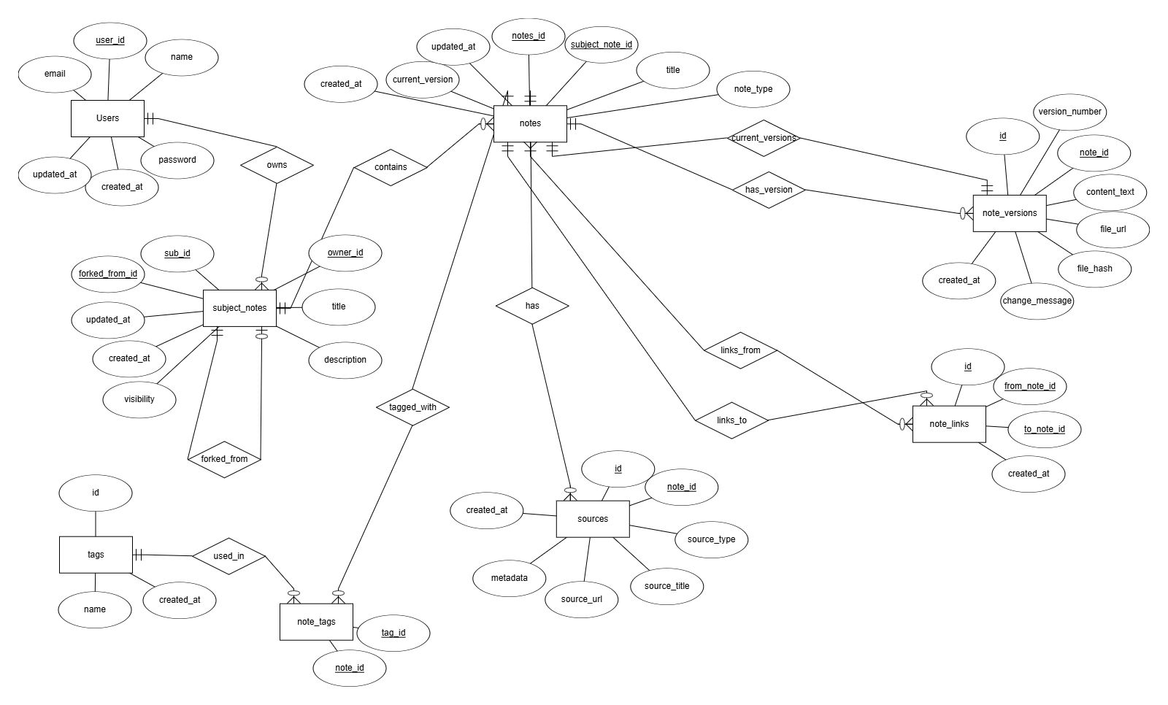

CHAPTER 4

CANVASES

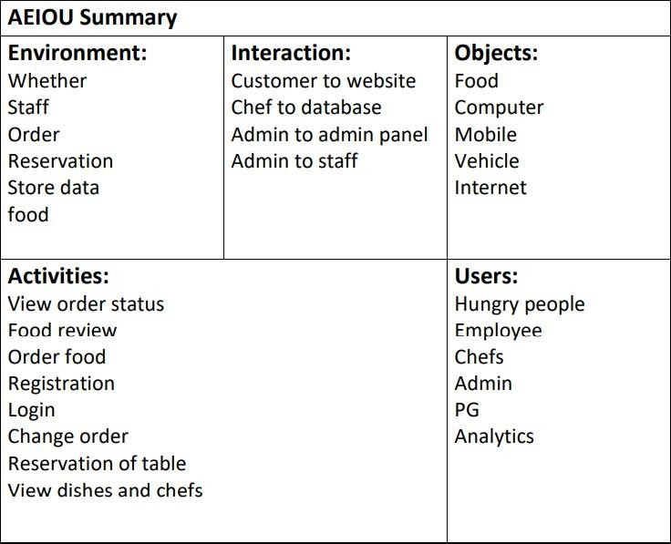
AEIOU :

EMPATHY :
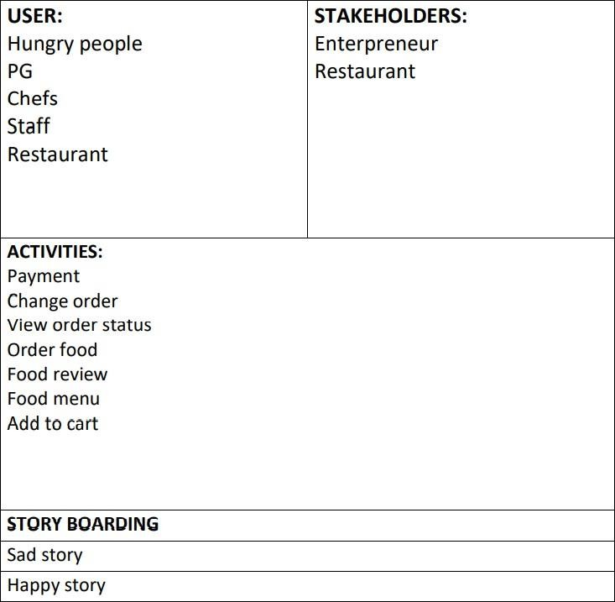

IDEATION CANVAS :
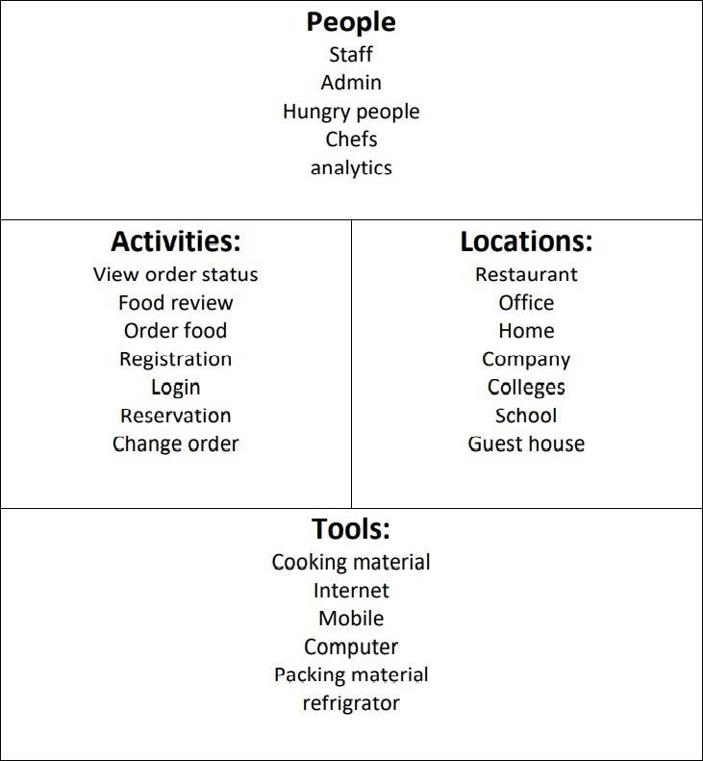

PRODUCT DEVELOPMENT :

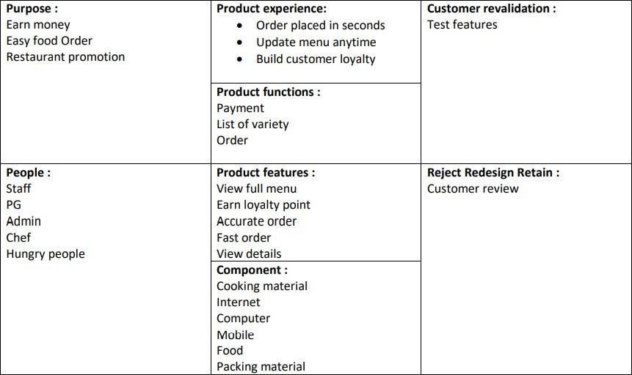

Learning need matrix :

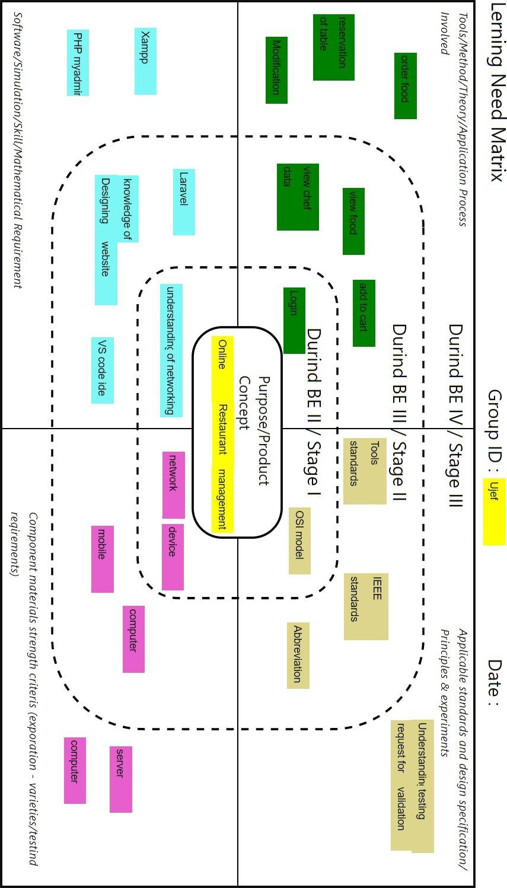

CHAPTER-5
Implementation

Entire implementation code for project is available in the following link : https://drive.google.com/file/d/1vtsjQQnzdrSBMTuiTUPgN0O9 EV5PDzJo/view?usp=drivesdk

CHAPTER-6
Conclusion And Future Scope

CHAPTER-7
References

